MBEA Summer Conference 2012
Flash CS5 Animation Introduction
Getting to Know Flash CS5

Tonya D. Skinner, Jackson Senior High School
7/24/2012

Flash CS5 Introduction Workshop—MBEA Summer Conference 2012
Part 1
Goal: Familiarize with workspace and apply basic shape drawing techniques.
Key Terms:
- Selection tool (pick up and move things; if item is deselected, move points or curve lines)
- Zoom drop down menu (or Control+ or Control- to zoom in/out)
- Timeline
- Properties panel
- Stage (where everything goes; can change size and background color)
- Classic workspace
- fps (frames per second)
- Layer
- Stroke (border outside; ink bottle to add to shape later)
- Fill (inside; paint bucket ; can only fill in closed shapes)
- Object Drawing Mode (for shapes; auto groups)
- Break Apart (Control+B to break apart grouped shapes)
- Close Large Gaps (for paint bucket)
- Snap to Objects (magnet button; for using drawing tools/shapes)
- Tools Used: Rectangle and Line

Procedure:
- Identify the parts of the screen (Timeline, Layers, Toolbox, Properties panel, Stage, Zoom)
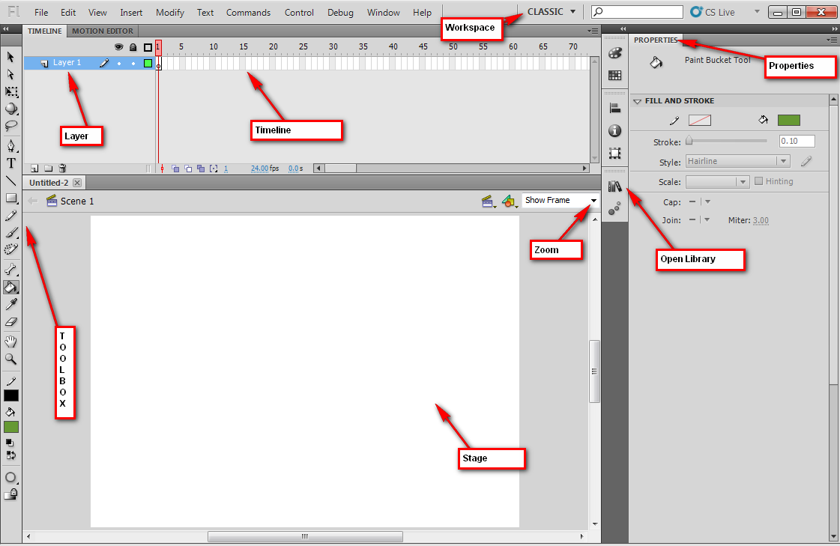
- Create a new Flash Actionscript 3 file. 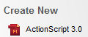
- Set workspace to Classic (Window>Workspace; reset if needed).
- On Layer 1, use the Rectangle tool draw a rectangle with a green fill and black stroke that fits the entire Stage.
  - To make it easier to draw even with the edges, turn on Snap to Grid (View> Snapping> Snap to Grid)
  - Be sure to set stroke Properties to Hairline and .10 size
  - NOTE: If using Object Drawing mode, your fill and stroke will be connected but if not, they are not grouped. You can “break apart” a grouped shape by pressing Control+B.
- Draw an additional rectangle inside that one to create the back wall: (Same settings)
- Use Line tool to draw lines connecting bottom corners; it helps to zoom in and helps to turn on Snap to Objects feature. Then, use Line tool again to draw the wallpaper border.
  - To draw a line straight across the screen, hold Shift key.
- Finally, use the Paint Bucket tool to fill in the carpet color and wallpaper border colors.
  - If you have trouble filling in, be sure to set Close Large Gaps to fill in (remember that an area has to be “closed” to fill.)
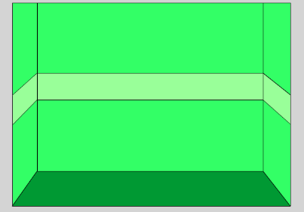
- Save as greenroom.fla to your project folder.

Part 2
Goal: Create grouped shapes with the Deco Brush, apply transformations, and create a simple symbol.
Key Terms:
- Keyframe (F6—solid black dot holding an item)
- Blank Keyframe (ready to hold stuff; empty circle on Timeline)
- Lock layer
- Rename layer (double click)
- Deco Brush (auto groups special shapes)
- Free Transform (Q—allows you to skew, rotate, or resize groups or selected items)
- Library (Control+L or F11—holds imported bitmaps, reusable symbols and other assets)
- Symbol (special items that are stored in library—can be graphic, movie clip or button; editable and changes all instances of the symbol in the movie)
- Instance (when you drag in a symbol from the Library)
- Shift (draws perfect circles, squares, or straight lines)
- Pencil (smooth, straighten, ink)
Warning! Stacking ungrouped shapes causes shapes to “eat” each other.
Procedure:
- Rename your layer (double-click Layer 1 and call it Room); create a new layer called Wallpaper.
- Lock the Room layer. 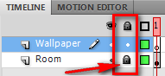
- Use the Deco Brush and set to Decorated Brush (effect) and 17: Cartoon Stars (advanced options). Choose a pattern color, and then click and drag to draw a set of stars on each edge wall and then draw across the back wallpaper stripe.
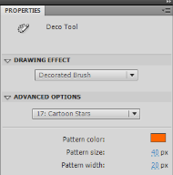
The Deco brush has some cool features. You can create fire/smoke animations, draw trees/flowers, draw skyscrapers, and make patterns. These are all automated!
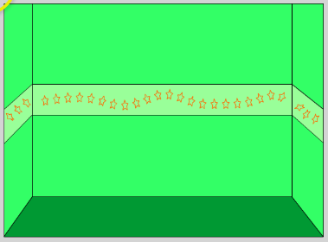
- Use the Selection arrow to move them if needed; each set of “click, drag, let go” creates another set of grouped shapes.

- Free Transform (Q) to get handles to skew, rotate, or resize your grouped stars.
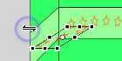 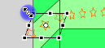
- Lock that layer; create a New Layer on top. 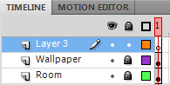
- Create a New Symbol (Insert> New Symbol or Control+F8) that is a movie clip called dot. Note that this will take you “inside” the dot symbol timeline so you can create your dot. Rename the layer inside there to be called dot instead of Layer 1.
  - Draw a circle (the Oval tool will be hiding under the Rectangle tool, so click and hold to find it; hold Shift to draw a perfect circle) that matches your stars. Use circle tool with no stroke (stroke set to null instead of a color)
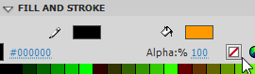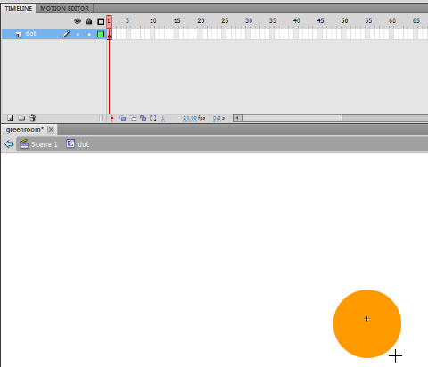
- Return to the Scene (Scene 1 or blue back button). 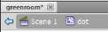
- Rename Layer 3 to be called dot. 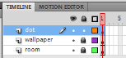
- On the dot layer, drag in 3 dots from the Library ( or F11 if it is not showing) and resize (use transform, Q, while holding Shift) and position (Selection arrow) as desired.
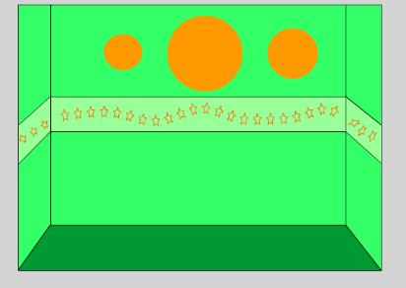 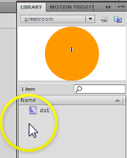
- Edit the dot Symbol in the Library (double click the picture of the dot to get in symbol edit mode):
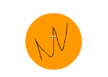
  - Lock the dot layer; Create a New Layer inside the dot symbol and use the regular Pencil tool to just scribble something on there. Note that your pencil might be set to straighten or another mode. If so, you can set it to ink to be able to better freehand the line.
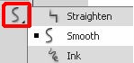
- Return to the Scene 1 screen. Your symbols should have updated!!
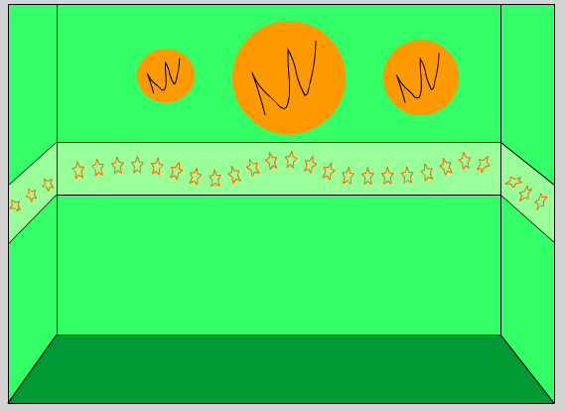
NOTE: If Flash it is much better to Undo than to try to fix things. If something doesn’t go right, just Control+Z and back up.
- Save your work!
Part 3
Goal: Editing symbols, reshaping shapes, apply shape and motion tweens.
Key Terms:
- Movie Clip (loops continuously; only previews when testing movie)
- Tweening (when Flash “fills in” what’s happening between two keyframes)
- Shape tween (best to not use stroke unless you used Object Drawing mode and it’s grouped)
- Test Movie (Control+Enter; actually publishes the file to your folder as a swf)
- Playhead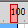 (red timeline handle to scrub through animation)
- Frame (F5—rectangle; indicates just “staying on screen”)
- Motion tween (use only with symbols; change placement and size or color properties)
Procedure:
- Double-click your biggest circle to go into symbol editing mode. Notice everything is greyed out except your circle and the timeline is now the symbol timeline. Inside the dot symbol, rename the top layer to be ink. 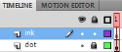
- (still inside symbol) On the dot layer, insert a keyframe at frame 24 and 48 (F6 in each; black dot). Note that all three dots will be the same size (1, 24, and 48):
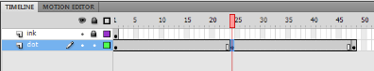
- In frame 24, make changes to the circle; reshape using black selection arrow or enhance with paint brush to make a “bigger” blob shape. You can also change the color if you like.
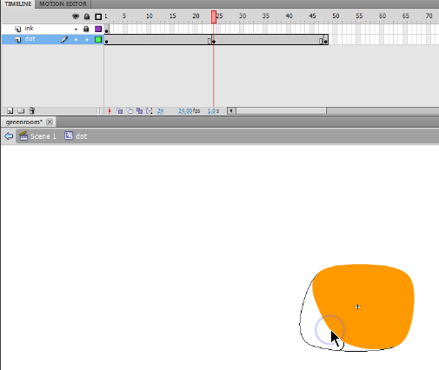
- Right click in between the black dots (between 1 and 24; repeat between 24 and 48) and create Shape Tween. Note that the timeline will turn green to indicate shape tween.
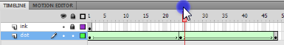
  - NOTE: You can still change that middle keyframe and it will all update. Thanks, elves.
- Notice the “ink” disappears after the first frame. To make it “stay on screen” during the whole animation, click in the final frame of the animation, which is 48, and on the ink layer, insert a Frame (F5). Because you inserted a frame and not a keyframe, if you make a change to the ink at all, it will change it for all the frames.
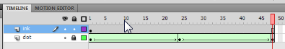
- Return to the Scene 1 screen where the main timeline (the room) is.
- Save! Preview the movie to see the tweens. Press Control+Enter. Exit the test movie popup after viewing.
- Reposition the dots on the dot layer to one side of the screen/resize (Q). Test movie again (Control+Enter).
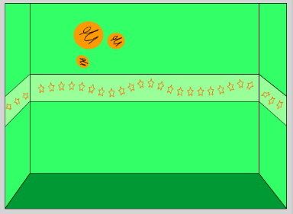
- Lock all layers on the main timeline (dot, wallpaper, and room). Create a new layer called butterfly.
- Import the graphic animation—animbfly.gif—to the Library (File>Import> Import to Library and browse to find the image). Note that this will create several items in the Library. Open it to see:
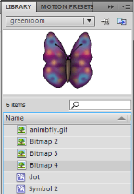 Note that it added several bitmaps (the ones with the tree icons) and a movie clip (it called it Symbol 2). The movie clip is what we will use. Rename it to be bfly. You can create a folder in the Library to hold those extra bitmaps if you wish. Just drag them in.
- Drag the bfly movie clip from the Library to the first frame of the butterfly layer on the main Timeline. We will animate this butterfly to fly across the screen in a minute, so position her just off Stage at the left. And, size her down a bit (use Free Transform/Q).

- We want this animation to last about 4 seconds or so (100 frames). So, add a Frame (F5) to the 100th frame of all the previous items (dot, wallpaper, and room layers) to that they “stay put” on the screen:
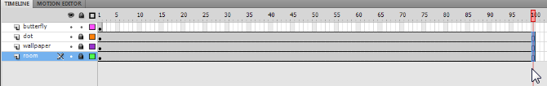
- On the butterfly layer, create a Motion Tween (right click the black dot, Create Motion Tween). Drag the blue box edge on the Timeline to the 100th frame.
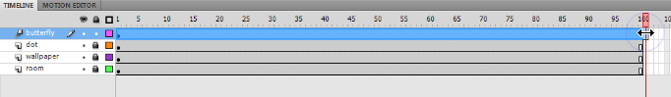
- Drag the playhead (red line) about a second in (24 frames or so) and reposition the butterfly (click and drag her; you can also rotate her, if desired). Repeat this process three more times in different spots with the butterfly off the screen towards the end:
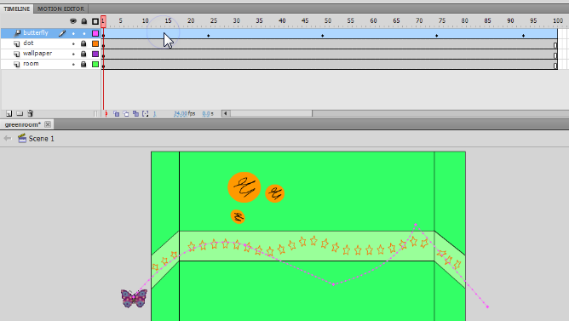
- To edit any of the straight lines to curves, using the Selection arrow point to the line (don’t click on them) and click and drag when you see a curve appear:
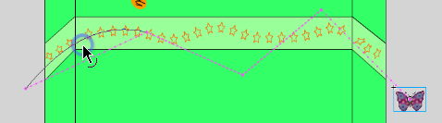
- Drag the playhead and you should see the butterfly fly across; however, the movie clip does not play (she actually flaps her wings!) until you test the movie. So, save and test it! Control+Enter!
- Notice that the movie plays and then repeats because that’s what Flash does. The butterfly will fly across and then the process will repeat (the movie replays). The shape tweens on the wall will continue to pulse. Exit the preview and save your work.

Part 4
Goal: Create and change scenes, add Actionscript using Code Snippets (stop and button), and create a button symbol.
Key Terms:
- Scene (plays to next scene automatically before looping; Window>Other Panels> Scene)
- Actions (F9)
- Button (States: Up, Over, Down, Hit)
- Pen tool
- Stroke styles (hairline, ragged, hatch, dashed, etc.)
- Actionscript
- Code Snippets
Procedure:
- Bring up the Scenes panel (Window>Other Panels> Scene) to add a second scene. Press the white piece of paper button to add a scene. Rename the scenes—roomscene and guy.
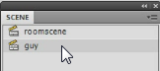
- Click on the guy scene to work on it. Notice it is blank and white. Use the Selection tool and click the background. In the Properties panel, set the Stage background color to a sky blue.
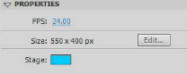
- Now, rename the layer clouds. Draw two clouds—one using the paintbrush (notice you can change size and shape of brush at the bottom of the toolbox; fill with paint bucket) and one using overlapping circles with no stroke. Notice that if Object Drawing is turned off, the circles combine to make one moveable cloud:
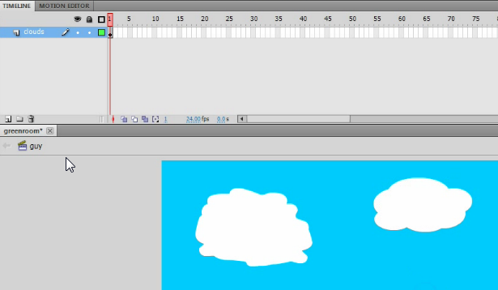
- Save and Test movie (Control+Enter) and you should very briefly see your clouds pop in after the first scene ends.
- Return to the first scene (roomscene). We are going to be creating a button to take us to the second scene, so we need to make the first scene stop. To do this, you must add Actionscript. This is done in the Actions panel (F9). We can use special Flash shortcuts called Code Snippets to do this easily.
  - Click at the ending frame, where we want it to stop (frame 100) on the top layer
  - Bring up the Actions panel (F9)
  - Click the Code Snippets button
  - A panel appears; find Timeline Navigation and double click on Stop at this Frame. This inserts a Stop action into the Actions panel (and a comment above it explaining codes)
  - Close the Actions panel and Code Snippets panel and Test Movie to be sure it stops. Note that movie clips do not stop and play even when the Timeline is stopped.
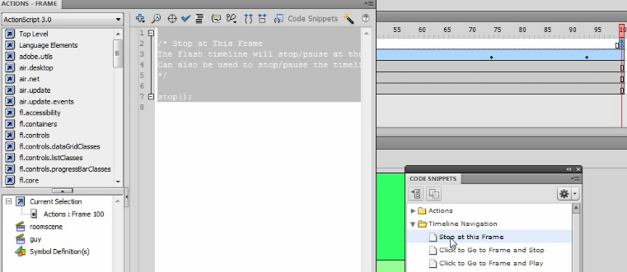
- Notice a little “a” on the timeline on a new layer that Flash created called Actions. 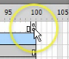
- Lock all layers. Create a new layer on the main Timeline in the roomscene. Name it button.
- Create a new symbol (Insert> New Symbol) called nextbutton. It should be a button type.
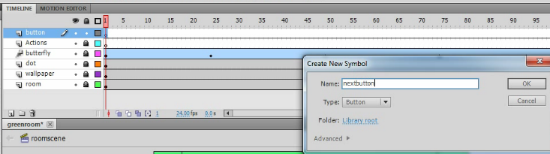

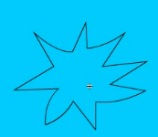
- Inside the button . Now, you will draw the button. In the Up frame (where the blank keyframe is), use the Pen tool and draw a starburst (click, let go, click, let go, etc.). Edit as needed with the Selection arrow. (NOTE: Can change stroke style in Properties panel; below is an example of a star with a Stippled stroke)
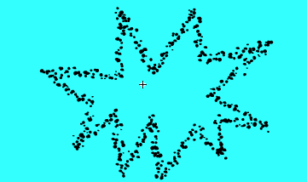

- Fill (Paint Bucket) in the shape with a color. Be sure Close Large Gaps is set.
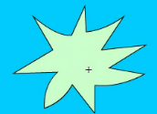
  - If you wanted to add text, be sure to do that on a separate layer.
- Rename the layer star (inside the button). Insert a keyframe (F6) on the Over state. Click off of it with the Selection arrow and change the inside fill color.
- Repeat the process again, changing the fill color in the Down state (Insert Keyframe first!).
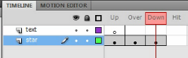 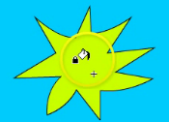
  - NOTE: The Up state is when the button is just sitting there; the Over state is when the mouse is pointing to it; the Down state is when the button is being clicked. Those are important to understand. You can just make a button with only the Up state, however. That’s all that is required. The Hit state is a whole separate thing. Basically, it means that it defines the area that ‘can’ be clicked to activate the button. This really only matters if you have a button that isn’t on a shape as clicking letters would otherwise have to be precise.
  - BONUS: You could change the star points on the states, add clipart, change words, etc.
- Return to the Stage on the roomscene. Drag the button from the Library to the button layer (be sure the rest are locked!). Position in the bottom right corner. Transform/resize as needed (Q).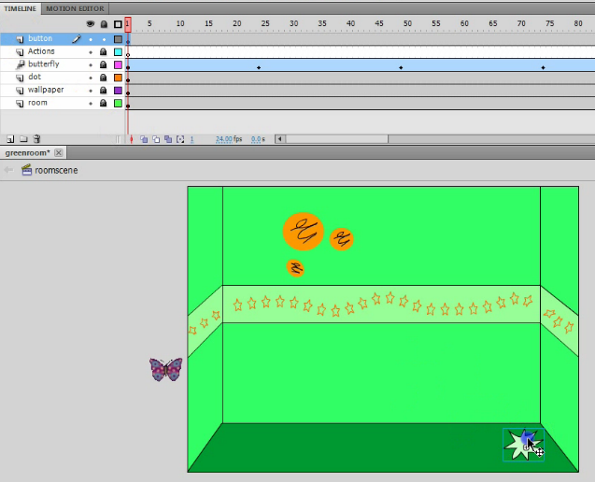
- Save and Test Movie (Control+Enter). If you click the button, nothing happens. Sadly. We have to “script” that. But, the color changes should happen (Up, Over, Down). Check that out and return to the timeline.
- Before we script the button, we need to give it an Instance name. It is needed for scripting. Click the button once with the Selection arrow and fill in the Instance name in the Properties panel:
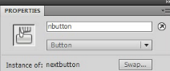 I called mine nbutton.

- While the button is active and the Timeline is in frame 1, bring up the Actions panel (F9) and click Code Snippets. To script a button, go to Timeline Navigation and find the one that says Click to Go to Next Scene and Play. Double click that and it should insert your code.
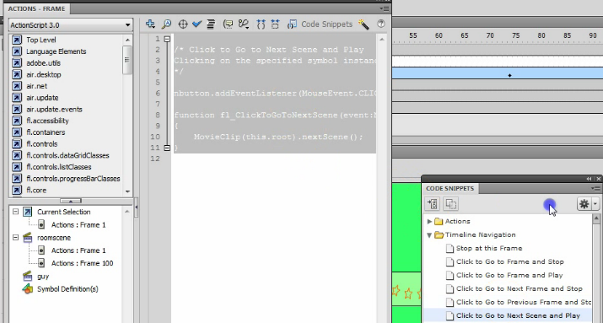
- Close those panels. Then, we can extend the second scene so we can test this to make sure it works. Switch to the guy scene (Scenes panel) and insert a Frame (F5) at 100. This will make the clouds stay on the screen for about 4 seconds so we can actually make sure the button is working.
- Go back to the roomscene. Notice that you have two Actionscript frames (with little a’s).
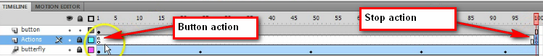
- Now, Save and Test Movie (Control+Enter) and the button should work, the clouds should sit there for 4 seconds, and then the movie should return to the first scene and replay!
- If all works, smile and save!
Bonus Fun You can modify the stroke (like on the button or whatever) in the Properties panel. It can be solid, dashed, dotted, and lots of other fun things!

Part 5
Goal: Create drawing from combined shapes, use Pen tool to create custom shape, and convert drawing to symbol.
Key Terms:
- Switching between scenes
- Drawing/modifying shapes and lines
- Overlapping shapes and removing strokes
- Pen tool
- Convert to Symbol (F8—select item first)
Procedure:
- Bring up the Scenes panel (Window>Other Panels> Scene) and be sure you are in the guy scene.
- Lock the clouds layer. Create a new layer called guyhead.
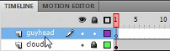
- Click on the guyhead layer. Choose the Oval tool and use a hairline black stroke and choose a skin color. Draw overlapping circles as shown to create a head with ears: (draw big and we’ll size down later! Note that if Snapping is bugging you, you can disable it under View> Snapping)
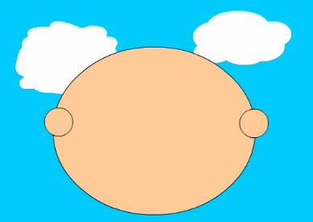 Then, use a rectangle at the bottom 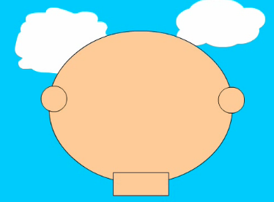
- Use the Selection arrow to pick the lines you need to delete and press Delete to remove them:
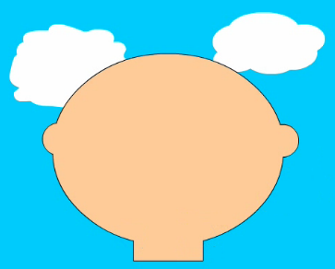
- Use the Line tool to draw in eyebrows, a nose, and a mouth line. You may also draw ear cracks.
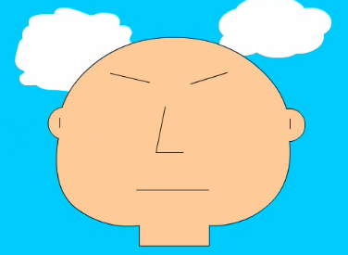
- Use the black Selection arrow to point to and curve the lines. It is helpful to zoom up close to do this. Add additional lines to create a mouth and eyes (make half the eye, curve, make second half) and fill (Paint Bucket) in the eyes and mouth with color. Use the Brush tool to add pupils.
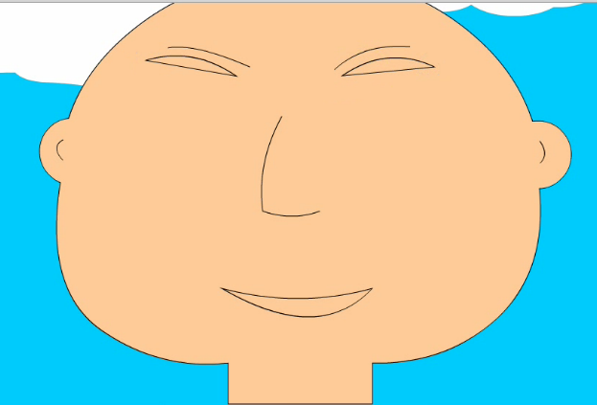 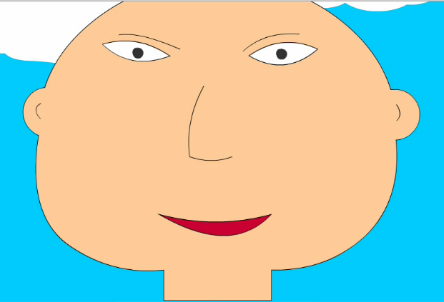
- Lock the guyhead layer; Create a new layer and call it hair. Then, use the Pen tool to create hair. Fill in (Paint Bucket) when finished. Remember, you can use the Selection arrow to modify the hair if needed.
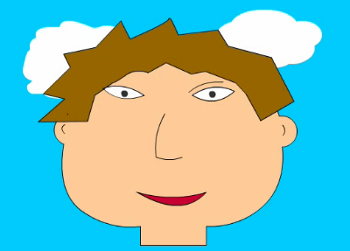 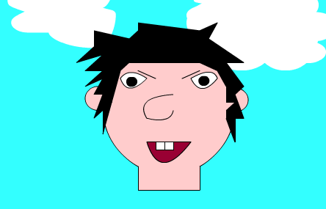
- Now, be sure the guyhead and hair layer are unlocked (clouds should be locked). Use the Selection arrow to draw a box around those to select them. Convert this to a movie clip symbol (F8) called guyhead1. Size down (Q) and reposition so you can draw the trunk.
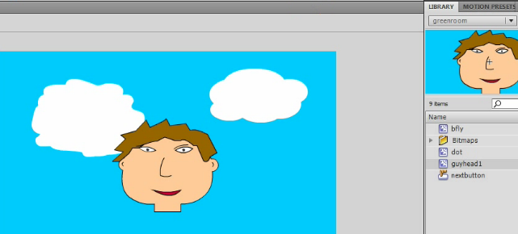
- Create a new layer called torso. Lock all the other layers. Use an Oval (or other shapes) to draw the torso and adjust with Selection arrow.
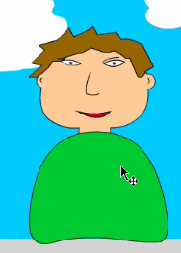 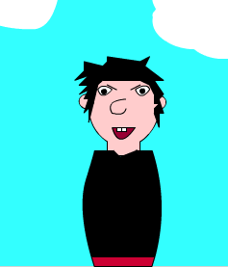
- Lock the torso. Create two new layers—leftarm and rightarm. Leftarm should be the topmost layer, then torso, then move rightarm below torso. Lock all layers except leftarm. Use the Pen tool to create the arm; fill with the same color as the shirt. Modify with Selection arrow.
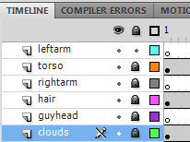 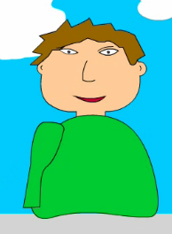 Double-click to select the arm and move it to position to check it; then move it off to the side a little bit for now.
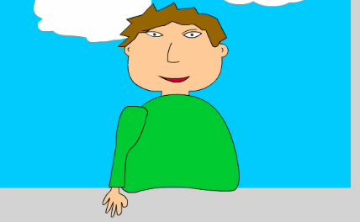
- Off to the side, draw a big hand using the Pencil tool.
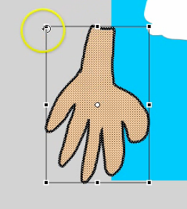 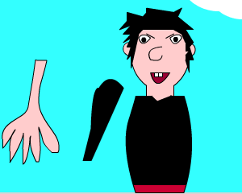
Then, select it (Selection arrow) and size down (Transform—Q).
- Move the hand in place where it goes. Then, select the arm (double-click), move it where it goes (do not deselect!), cut it (Control+X) and paste it in place (Edit>Paste in Place) and it should be in position in front of the hand where it goes. They will “glue” together so be careful. Pasting it should put the arm in front of the hand.
- Now, click off the leftarm layer for a second (click another layer) and click back on the leftarm layer (this selects everything on the layer, arm + hand). Right click and copy the arm.
- Lock the leftarm layer and unlock the rightarm layer. Click on the rightarm layer and paste the arm. It will be behind the body since that layer is behind the torso layer. Use the Selection arrow to move it off to the right for a moment.
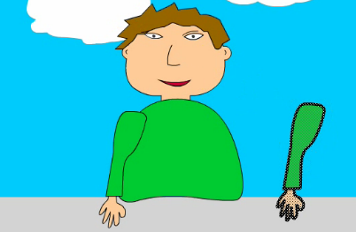
- To flip the arm around, just click Modify> Transform> Flip Horizontal. This “mirror” flips it. Then, position it where it should go. Feel free to Free Transform as needed (Q).
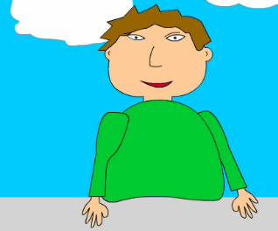 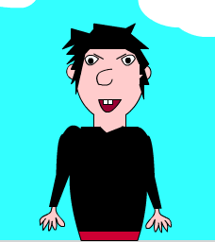
- Save!

Lesson 6
Key Terms:
- Bone tool (can animate an ungrouped drawing)
- Armature Layer (created by Bone tool; edit armature with Selection arrow)
Procedure:
- Lock all layers before we go on…just to be safe.
- Unlock rightarm layer and select the right arm with the Selection arrow (draw a box around the hand and sleeve). Click the Bone tool.
- Click at the shoulder and drag to the elbow; click elbow to the wrist; and then click wrist to the top of the fingers. It will group them and appear as follows:
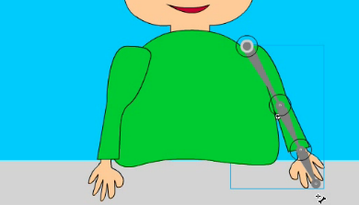
- Notice that it has created a new layer called Armature and has moved the arm from the rightarm layer to that Armature layer. It is also a “tween” looking layer (shaded green).
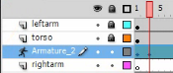
- Just like with a Motion Tween, you will move the Playhead a few frames, position the arm by dragging the bones, move the playhead again, reposition, etc. It will tween between positions automatically. For the right arm, just wiggle it around a little bit. Nothing dramatic.
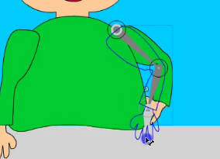 NOTE: If you need to move the arm, use the keyboard arrow keys since the Selection tool will move the armature joints. If the bone/joints are off, use the white arrow—Subselection tool—to move those points.
- Lock this arm and unlock the other arm. Then, repeat the process. Select the left arm, use the Bone tool, drag the joints, and then begin animation with the Selection tool while scrubbing the Timeline (remember, it will create an Armature layer for animating). The left arm should lift up and wave back and forth a few times. Then, he should put his arm back down. Use your imagination.
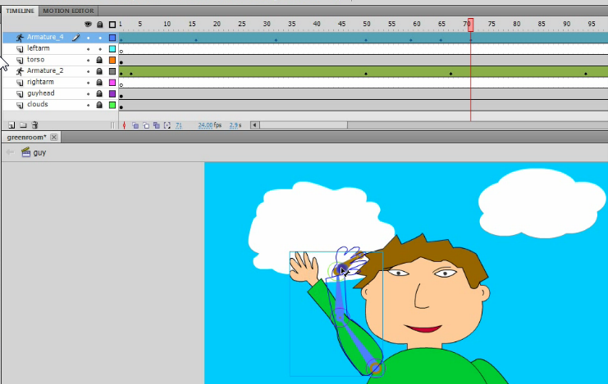
- Drag the playhead to the beginning (Frame 1) and press Enter to preview the Timeline animation. If it looks okay, save it! Sometimes if the Armature is too complicated or the arm overlaps itself, odd white spaces will occur. So, try to avoid that and, if you see it in preview, try to reposition.
- Test movie (Control+Enter) and see if everything works.
- NOTE: Remember, you can still edit the head (it’s a symbol) in the Library if you decide to change the expression or other features. You can also unlock the torso layer and edit that (draw lines and make stripes, etc.). Make it yours!
Eraser Notes
If you change your mind or want to erase, there are a few things to note. The eraser only erases drawn objects. It does not erase symbols or bitmaps. If you have a symbol and double-click to get into symbol editing where it was drawn, you can edit, but not on the main Stage. The eraser has a few modes as well for erasing strokes or fills without messing with the other part--
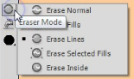
Bonus Material—Motion Path (previously motion guide)
Key Terms:
- Motion guide
- Orient to path
Procedure:
- In the guy scene, create a new layer called butterfly. Lock all other layers.
- We want the butterfly to wait to fly in and not to appear until frame 20. So, insert a Blank Keyframe (right click) at frame 20 on that layer. A hollow dot should appear.
- Drag the bfly movie clip from the Library onto the Stage while clicked on frame 20 of the butterfly layer. Position off stage left. Size down as needed (Q).
- Grab the Pencil tool. Draw a path from the butterfly across the scene and off the Stage.
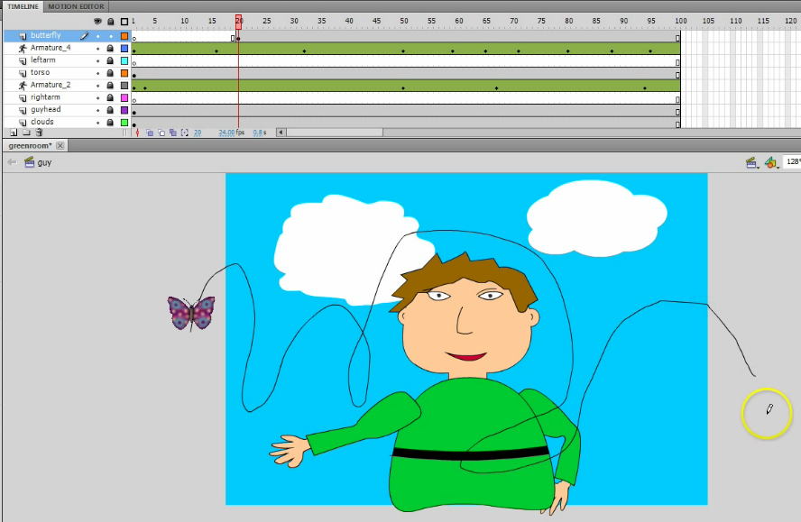
- After drawing the path, take the Selection arrow and double-click the path to select it. Then, cut it (Control+X). We will paste it in a little bit.
- Now, right click the actual butterfly and Create Motion Tween. Then, scrub the Playhead to near the end of the tween (97 or so) and reposition the butterfly to off stage right.
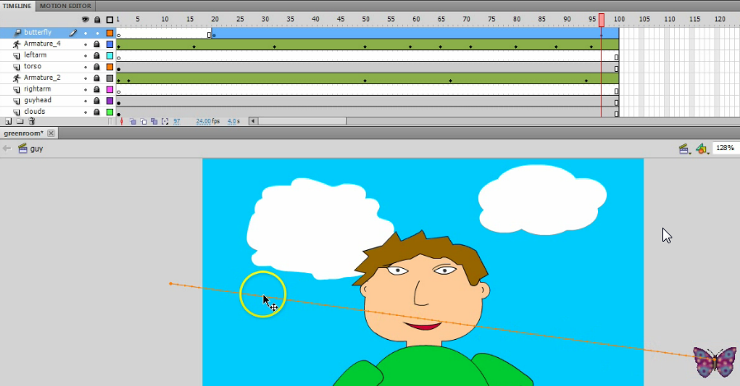
- Now, click the colored/dotted motion tween line with the Selection arrow. Then, click Edit> Paste in Place or Control+V and your path you drew earlier should replace the straight line! You may be prompted to Optimize the Path (that’s okay).
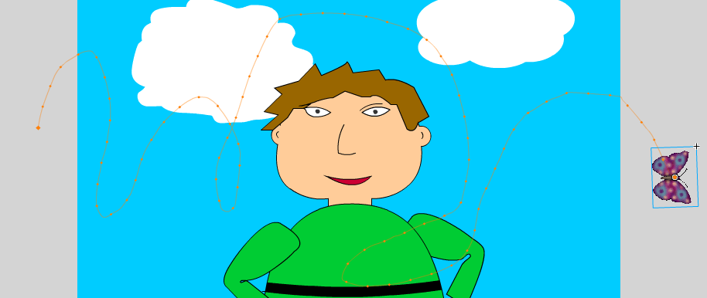
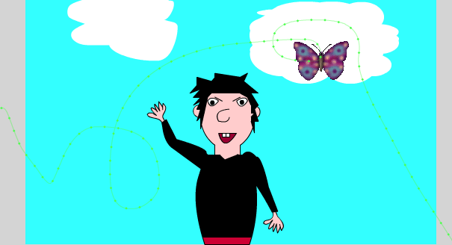

- To make the butterfly “turn” towards the path as it goes, you can click anywhere in the blue motion tween area on the Timeline and check Orient to Path on the Properties panel:
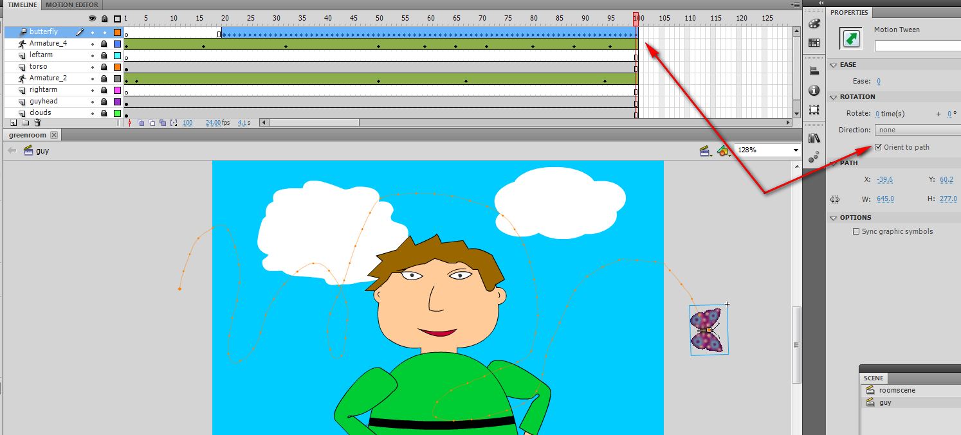
NOTE: It will add a bunch of tiny keyframes in the motion tween where it turns your butterfly.
- That should do it. Save it and test it!

Resource for GIF animation used in the project:
http://www.millan.net/anims/giffar.html (bfly animation)
Workshop Website (can download the GIF and link to the screencasts or view example):
https://sites.google.com/site/deseworkshops2012skinner/ (click Flash Workshop at left)
Tutorial Site (my screencast of this workshop, step by step on-screen demo):
http://www.screencast-o-matic.com/channels/cXi0fOVuS
Contact Me:
skindawg
@tonyaskinner
http://lessonplans.btskinner.com
skindawg2@gmail.com or tskinner@jackson.k12.mo.us

